
RESEARCH FINANCIAL & compliance SERVICES REFERENCE GUIDE FOR NEW GRANTEES

Revised May 2022

TEXAS SOUTHERN UNIVERSITY
3100 CLEBURNE AVENUE • HOUSTON, TEXAS 77004
RESEARCH FINANCIAL SERVICES
HANNAH HALL 315

RESEARCH FINANCIAL & compliance SERVICES REFERENCE GUIDE FOR NEW GRANTEES

Table of contents
Table of Contents
Sample of Grant Award Acknowledgement……….………………………………..……3-4
Grant Fund Request Form……………………………………………………...….…..……5
Steps to Get to the Grant Fund Request Form……………………….…………….6-7
Banner Access and Signature Approval…………………………….………………….…8-9
Banner Account Codes………………………………………………………………....10-11
Human Resources Guide………………………………………………………... ..…...12-26
Position Request (PR) Form……………………………………………….…….…27
Employee Exception Request (EER) Form…………………….………….……….28
Supplemental Form…………………………….……………………………….29-30
Travel and Travel Card……………………………….…………………….……….....31-33
Request for Authority to Travel at University Expense Form….…………….....….34
Travel Card Centrally Billed Account CBA) ……………………………….….......35
Application/Approval Form for Department Travel Card………………………….36
General Counsel………………………………………………….……………….…....37-38
Legal Management System…………………………………………………………39
Requisition Forms…………………………………………………….……………..…40-41
Information about Purchase Order, Requisition Forms and Procurement Services……………………………….……………………………….…………….….....42
Direct Pay Voucher (DVP)………………………………………………………….…….43
Granted Closeout Form………………………………………………………….. ..….44-46

Sample of grant award acknowledgement letter

TEXAS SOUTHERN UNIVERSITY
3100 CLEBURNE AVENUE • HOUSTON, TEXAS 77004

OFFICE OF THE
SENIOR ASSOCIATE VICE
PRESIDENT FOR RESEARCH
(713) 313-7812

Date
Address of Grantee
Dear Grantee:
Congratulations! I am pleased to inform you that your research award for the project “Project Title Name” has been approved for continued funding in the amount of $_________ by the “Funding Agency Name” for the period of “Grant Dates”. In this regard, a copy of the grant letter and guidelines applicable to the grant are enclosed.
Fund Number Assigned: ____; Organization Number: _____; Program Number: __
Also, be reminded that a Subcontract or Independent Consultant agreement must be in place if your project requires subcontracting to third party entities. Please contact the Office of Research, Department of Research Funding and Pre-award Services to discuss payments and agreements needed to establish legal entity between Texas Southern University and a Subcontractor/Independent Consultant.
Please be reminded also that expenditures under the grant should be made during the performance period of the award and should conform to the approved budget. Technical reports are required by the government and should be prepared in accordance to the format prescribed and should be submitted within the indicated deadlines. A copy of your technical reports should be sent to the Office of Research, Hannah Hall 310.
Again, congratulations and best wishes for a successful program. If additional information or assistance is needed, please let me know.
Sincerely,

Omonike A. Olaleye, Ph.D., MPH
Senior Associate Vice President for Research

Cc: Dr. Michelle Penn-Marshall – Vice President for Research and Innovation
Ms. Diane Lewis – Director, Research Financial Services

Grant fund request form

www.tsu.edu/about/administration/division-of-academic-affairs-and-research/research/pdf/grant-fund-request-form.pdf

Steps to get grant fund Request form

GRANT
Once you receive the Grant Award Acknowledge Letter, you should follow these steps:
- Go to Texas Southern University Home Page (http://www.tsu.edu)
- Click the down arrow on the tab About
- Click Administration
- Scroll to the middle of the page and click on Division of Academic Affairs and Research
- On Left, click the + sign on Research
- Then click, Research Financial & Compliance Services
- On the right-hand side, you will click on the tab labeled Forms
- Click on Grant Fund Request Form

BANNER ACCESS AND SIGNATURE APPROVAL

WELCOME TO TSU BANNER WEB SERVICE

www.tsu.edu/about/administration/office-of-information/banner-mytsuweb/index.html

Texas Southern University Home Page (www.tsu.edu)
- About
- Administration
- Office of Information Technology
- Banner & MYTSU

Banner Access and Signature Approval
Banner Access: Contact Rena F. Robinson (713)313-7646 or email Rena.Robinson@tsu.edu

Required signature approval: Contact your College Business Administrator

BANNER ACCOUNT CODES

www.tsu.edu/about/administration/finance/departments/procurement-services/pdf/most-commonly-used-account-codes.pdf

COMMONLY USED ACCOUNT CODES
HUMAN RESOURCES GUIDE

(CONTACT HUMAN RESOURCES TO ANSWER ANY QUESTIONS)

https://hr.tsu.edu/forms-tools/

TRAVEL AND TRAVEL CARD

www.tsu.edu/about/administration/forms/procurement-services.html

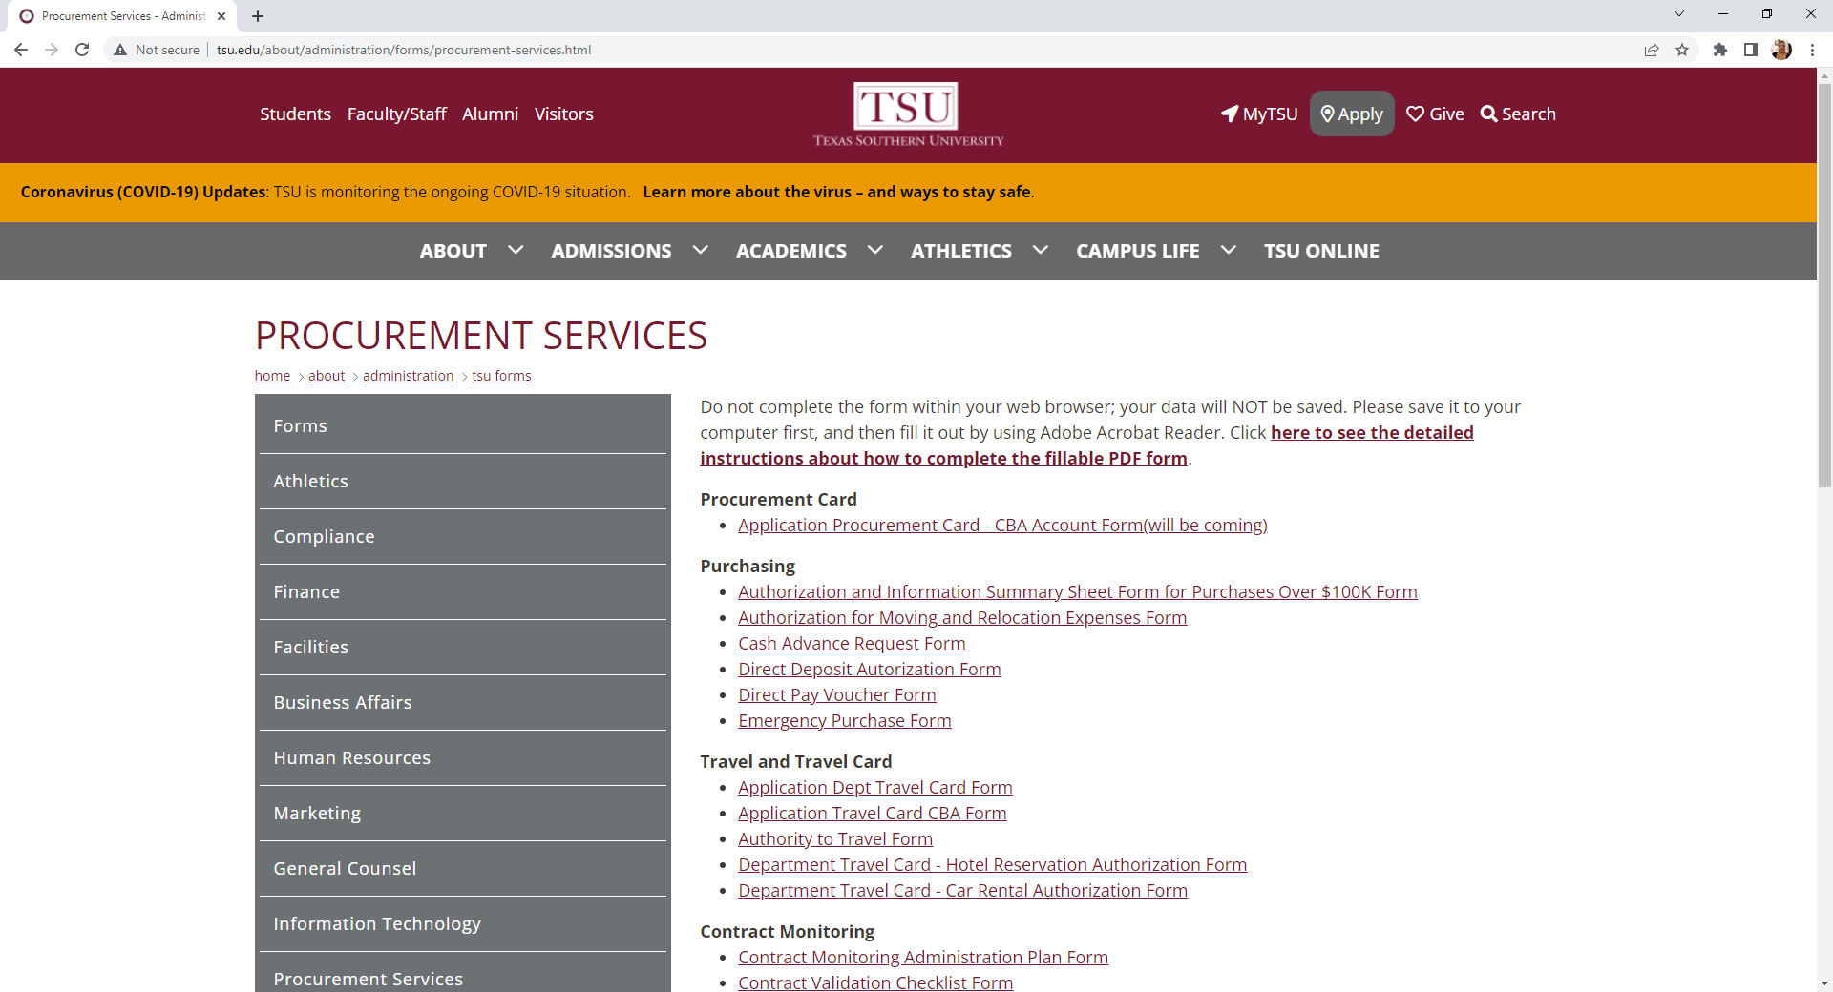

Travel services – concur

Log on to

Tsu.edu/about/administration/finance/departments/procurement-services/index.html

GENERAL COUNSEL

www.tsu.edu/about/administration/general-counsel/index.html

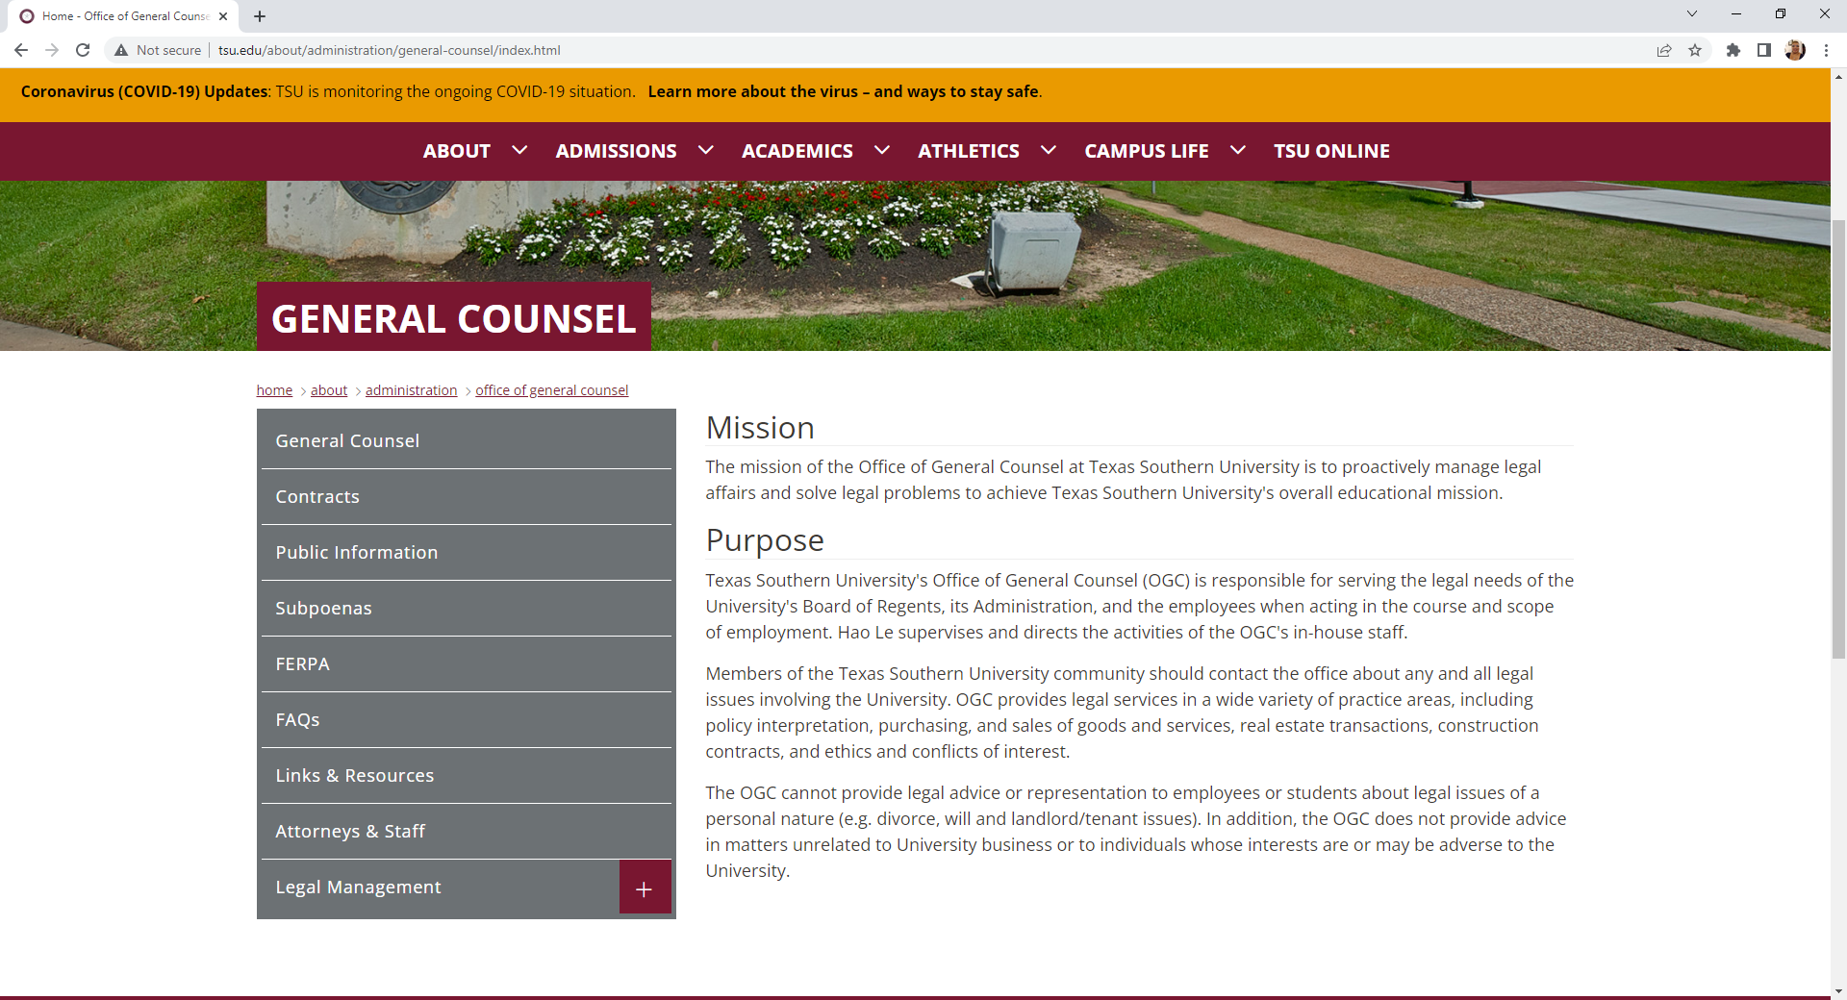
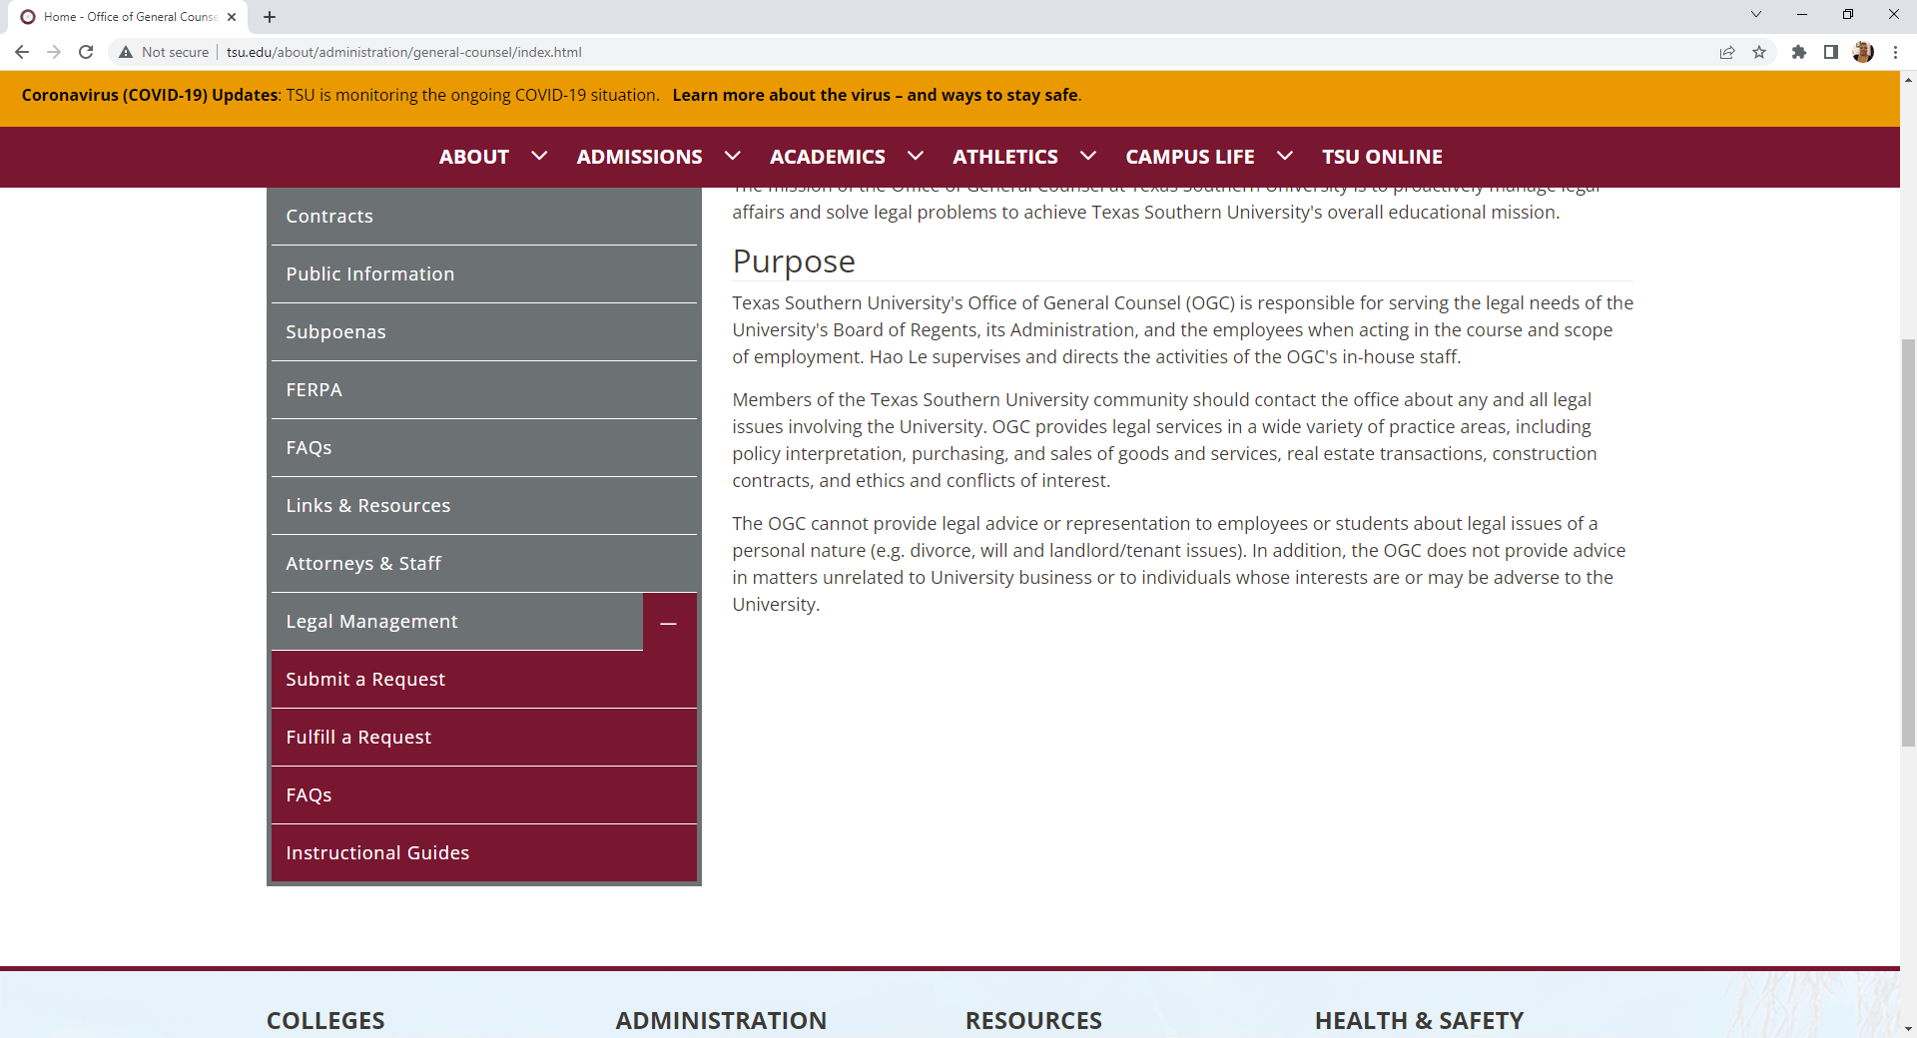

LEGAL MANAGEMENT SYSTEM

www.tsu/about/administration/general-counsel/legal-management/index.html

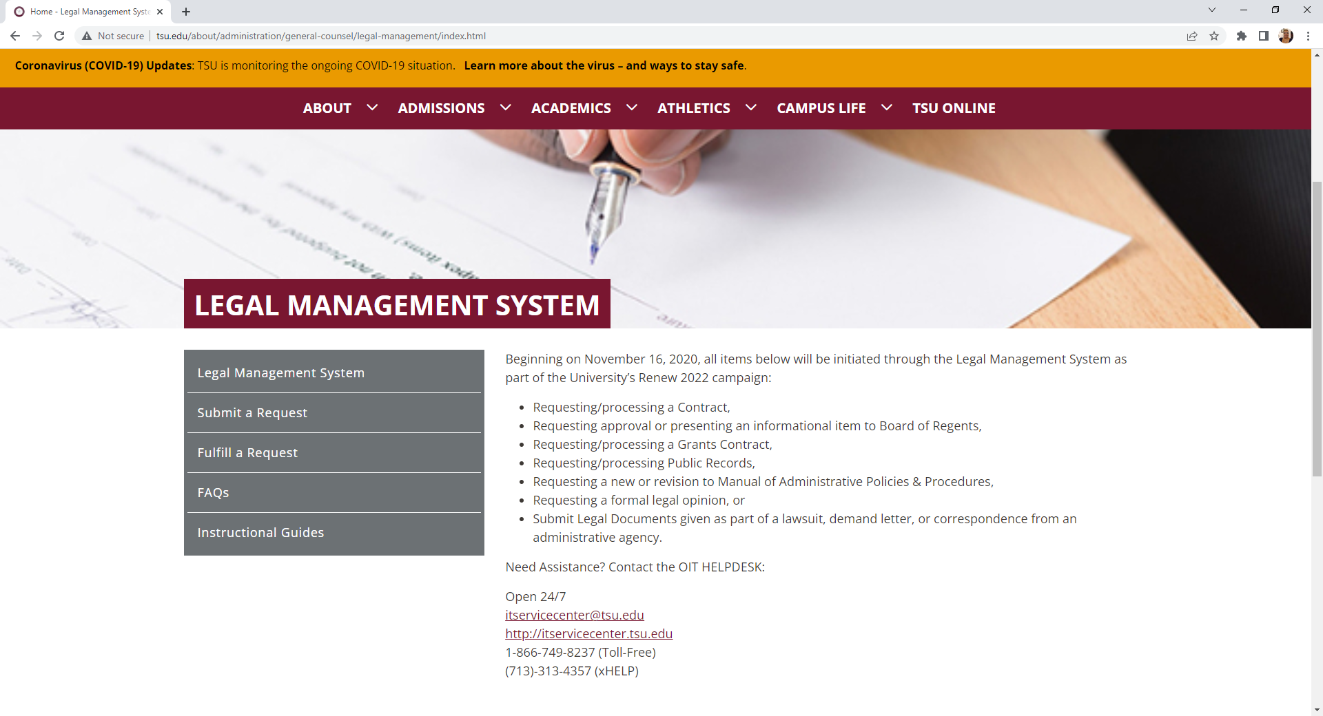

REQUISITION FORM

PURCHASE ORDER
Establishes a contractual relationship between Texas Southern University and a vendor for the purchase of goods and/or services. The Purchase Order is created and issued vendors by the Procurement Services Office from requisition submitted by Principal Investigator (PI) or Project Director (PD) and other universities.

REQUISITION FORM
Used to create a request for the purchase of goods and/or services.
http://www.tsu.edu/about/administration/finance/departments/procurement-services/pdf/paper-requisition-template.pdf

PROCUREMENT SERVICES
The department responsible for creating and issuing purchase orders to vendors based on requisitions submitted by Principal Investigator (PI) or Project Director (PD), and other University Personnel.
http://www.tsu.edu/about/administration/finance/departments/procurement-services/index.html

DIRECT PAY VOUCHER (DPV)

(Note: Request DPV Training Manual from the Office of Accounts Payable)
http://www.tsu.edu/about/administration/finance/departments/procurement-services/pdf/direct-pay-voucher.pdf

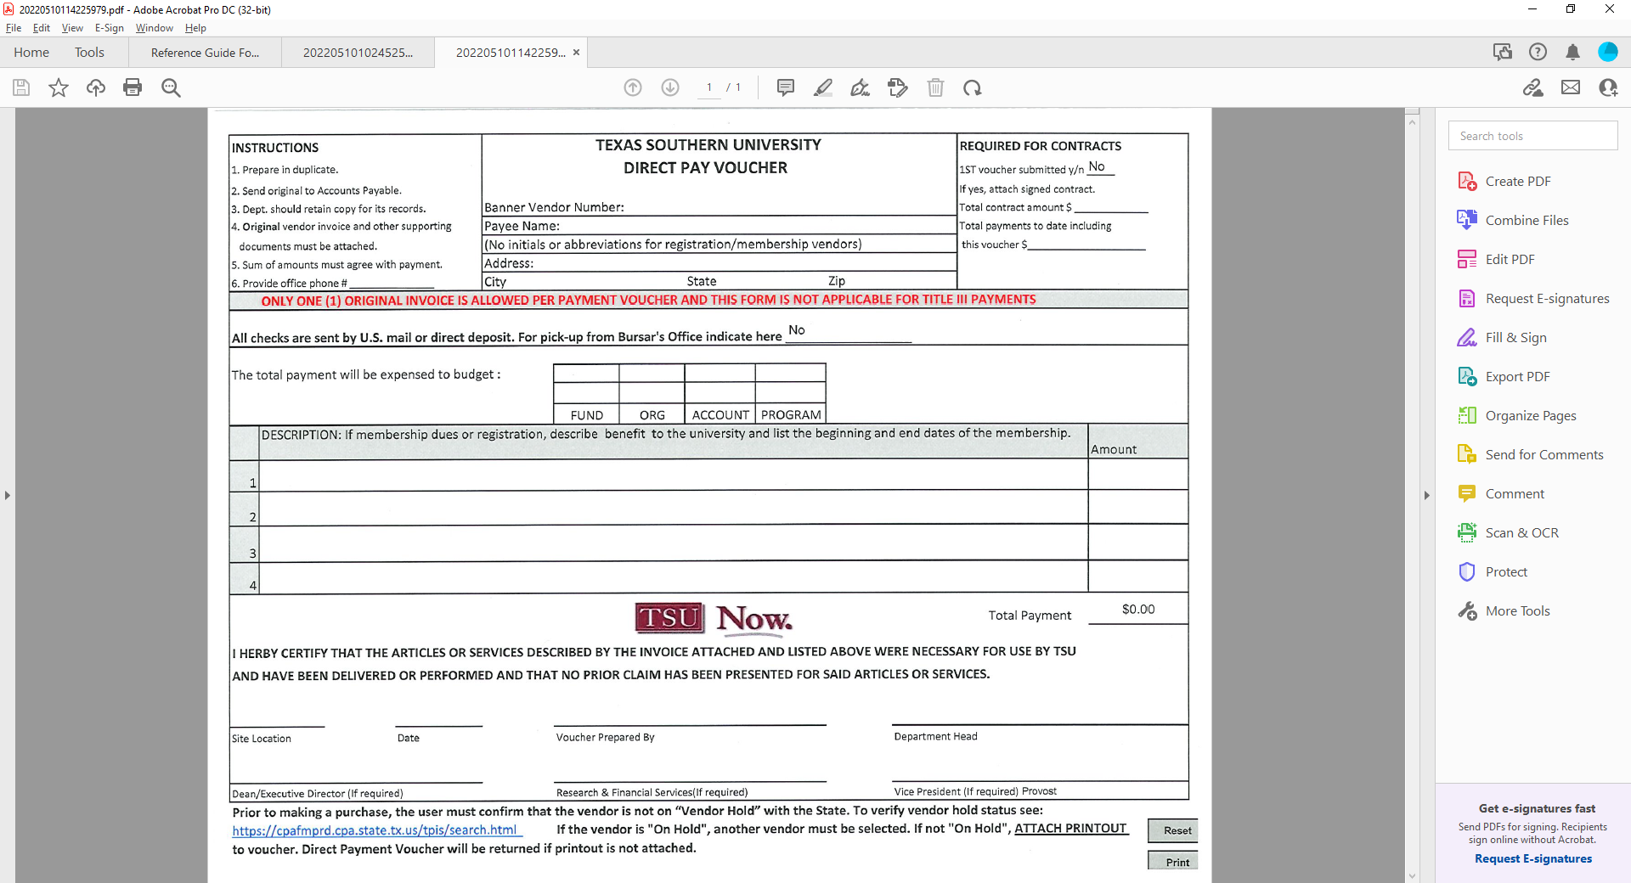

GRANT CLOSEOUT FORM

